Insert your name, centre number and candidate number into the header above.
Save this evidence document as evidence_ followed by your centre number_ candidate number. For example: evidence_ zz999_9999.doc
Screenshots or program listings must be copied into appropriate cells in the following tables.
Examiners must be able to read the contents including any screenshots without the use of a magnifying glass. Answers that are not readable or missing will not be awarded any marks.
Save this evidence document at regular intervals, for example, every 10 minutes.
Question 1
Part 1(a)
{global DataStored
global NumberWords
WordArray=[]
NumberWords=0
def ReadWords(FileName):
global DataStored
global NumberWords
try:
File=open(FileName,"r")
for line in File:
WordArray.append(line.strip())
NumberWords=NumberWords+1
NumberWords=NumberWords-1
File.close()
except IOError:
print("Fiel Doesn't Exists")

}

Part 1(b)
{userinp=input("Enter east,medium or hard:")
if userinp.lower()=="easy":
FileName="Easy.txt"
elif userinp.lower()=="medium":
FileName="Medium.txt"
else:
FileName="Hard.txt"
ReadWords(FileName)

}

Part 1(c)(i)
{def Play():
global NumberWords
global WordArray
print(WordArray[0],"The main word")
print(NumberWords,"Number of Answers")
Count=0
Flag=False
while Flag==False:
userinp=input("Enter Word:")
if userinp.lower()=="no":
Flag==False

else:
AnswerFlag=False
for x in range(1,NumberWords+1):
if WordArray[x]==userinp.lower():
print(WordArray[x],"is an answer")
Count=Count+1
WordArray[x]=""
AnswerFlag=True
if AnswerFlag==False:
print("It is not the answer")

}

Part 1(c)(ii)
{def Play():
global NumberWords
global WordArray
print(WordArray[0],"The main word")
print(NumberWords,"Number of Answers")
Count=0
Flag=False
while Flag==False:
userinp=input("Enter Word:")
if userinp.lower()=="no":
Flag==False

else:
AnswerFlag=False
for x in range(1,NumberWords+1):
if WordArray[x]==userinp.lower():
print(" Yes it is an answer")
Count=Count+1
WordArray[x]=""
AnswerFlag=True
if AnswerFlag==False:
print("It is not the answer")
percentage=int((Count/NumberWords)*100)+"%"
print(percentage)
for x in range(1,NumberWords+1):
if WordArray[x]!=userinp.lower():
print(WordArray[x])

}

Part 1(d)(i)
{WordArray=[]
NumberWords=0
def ReadWords(FileName):
global NumberWords
global WordArray
File=open(FileName,"r")
FirstLine=File.readline().strip()
File.close()
WordArray=FirstLine.split()
NumberWords=len(WordArray)
ReadWords(userinp)
Play()
}

Part 1(d)(ii)
{ 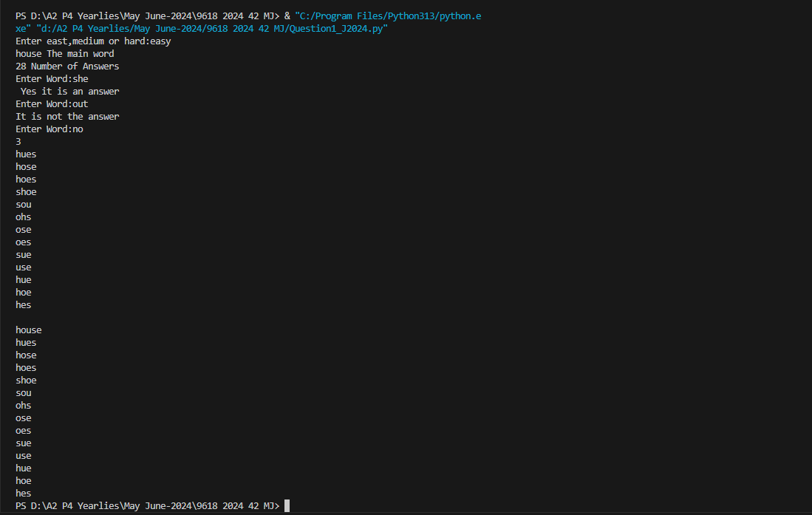}

Part 1(d)(iii)
{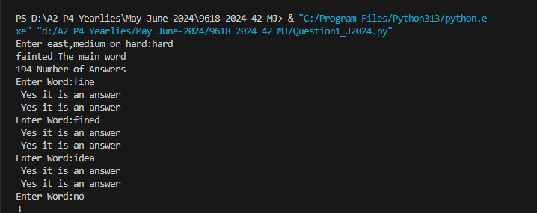 }

Question 2
Part 2(a)(i)
{class Node():
#PRIVATE LeftPointer:INTEGER
#PRIVATE Data:INTEGER
#PRIVATE RightPointer:INTEGER
def __init__(self,Data):
self.__Data=Data
self.__LeftPointer=-1
self.__RightPointer=-1
}

Part 2(a)(ii)
{ def GetLeft(self):
return self.__LeftPointer
def GetRight(self):
return self.__RightPointer
def GetData(self):
return self.__Data
}

Part 2(a)(iii)
{ def SetLeft(self,NewLeftPointer):
self.__LeftPointer=NewLeftPointer
def SetRight(self,NewRightPointer):
self.__RightPointer=NewRightPointer
def SetData(self,NewData):
self.__Data=NewData
}

Part 2(b)(i)
{class TreeClass():
#PRIVATE Tree:ARRAY[0:19]OF Node
#PRIVATE FirstNode:INTEGER
#PRIVATE NumberNodes:INTEGER
def __init__(self):
self.__FirstNode=-1
self.__NumberNodes=0
self.__Tree=[]
for x in range(20):
self.__Tree.append(Node(-1))
}

Part 2(b)(ii)
{ def InsertNode(self,NewNode):
if self.__NumberNodes>19:
self.__Tree[self.__NumberNodes]=NewNode
if self.__FirstNode==-1:
self.__FirstNode=0
else:
CurrentPointer=self.__FirstNode
Placed=False
while Placed==False:
if NewNode.GetData()<self.__Tree[CurrentPointer].GetData():
if self.__Tree[CurrentPointer].GetLeft()==-1:
self.__Tree[CurrentPointer].SetLeft(self.__NumberNodes)
Placed=True
else:
CurrentPointer=self.__Tree[CurrentPointer].GetLeft()
else:
if self.__Tree[CurrentPointer].GetRight()==-1:
self.__Tree[CurrentPointer].SetRight(self.__NumberNodes)
Placed=True
else:
CurrentPointer=self.__Tree[CurrentPointer].GetRight()
else:
self.__NumberNodes=self.__NumberNodes+1
}

Part 2(b)(iii)
{ def OutputTree(self):
if self.__NumberNodes==0:
print("No Nodes")
else:
for x in range(self.__NumberNodes):
LeftP=self.__Tree[x].GetLeft()
RightP=self.__Tree[x].GetRight()
DataP=self.__Tree[x].GetData()
print("LeftPointer",LeftP)
print("RightPointer",RightP)
print("Data",DataP)
}

Part 2(c)(i)
{TheTree=TreeClass()
}

Part 2(c)(ii)
{TheTree.InsertNode(Node(10))
TheTree.InsertNode(Node(11))
TheTree.InsertNode(Node(5))
TheTree.InsertNode(Node(1))
TheTree.InsertNode(Node(20))
TheTree.InsertNode(Node(7))
TheTree.InsertNode(Node(15))
Temp=TheTree.OutputTree()
print(Temp)
}

Part 2(c)(iii)
{Copy and paste screenshot for question 2(c)(iii) here}

Question 3
Part 3(a)
{ #DECLARE NumberArray:ARRAY[0:6]OF INTEGER
NumberArray=[100,85,644,22,15,8,1]
}

Part 3(b)(i)
{def RecursiveInsertion(IntegerArray,NumberElements):
if NumberElements<=1:
return IntegerArray
else:
RecursiveInsertion(IntegerArray,NumberElements-1)
LastItem=IntegerArray[NumberElements-1]
CheckItem=NumberElements-2
LoopAgain=True
if CheckItem<0:
LoopAgain=False
else:
if IntegerArray[CheckItem]<=LastItem:
LoopAgain=False
while LoopAgain:
IntegerArray[CheckItem+1]=IntegerArray[CheckItem]
CheckItem=CheckItem-1
if CheckItem<0:
LoopAgain=False
else:
if IntegerArray[CheckItem]<=LastItem:
LoopAgain=False
IntegerArray[CheckItem+1]=LastItem
return IntegerArray
}

Part 3(b)(ii)
{Temp=RecursiveInsertion(NumberArray,7)
print("Recursive",Temp)
}

Part 3(b)(iii)
{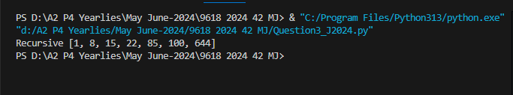 }

Part 3(c)(i)
{def IterativeInsertion(IntegerArray,NumberElements):
while NumberElements>0:
LastItem=IntegerArray[NumberElements-1]
CheckItem=NumberElements-2
LoopAgain=True
if CheckItem<0:
LoopAgain=False
elif IntegerArray[CheckItem]<=LastItem:
LoopAgain=False
while (LoopAgain):
IntegerArray[CheckItem+1]=IntegerArray[CheckItem]
CheckItem=CheckItem-1
if CheckItem<0:
LoopAgain=False
elif IntegerArray[CheckItem]<=LastItem:
LoopAgain=False
IntegerArray[CheckItem+1]=LastItem
NumberElements=NumberElements-1
return IntegerArray
}

Part 3(c)(ii)
{Sorted2Array=IterativeInsertion(NumberArray,len(NumberArray))
print("Iterative",NumberArray)
}

Part 3(c)(iii)
{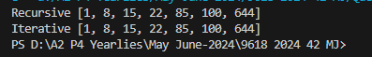 }

Part 3(d)(i)
{def BinarySearch(IntegerArray,First,Last,ToFind):
if First>Last:
return -1
else:
Middle=int((Last+First)/2)
if IntegerArray[Middle]==ToFind:
return Middle
elif IntegerArray[Middle]>ToFind:
return BinarySearch(IntegerArray,First,Middle-1,ToFind)
else:
return BinarySearch(IntegerArray,Middle+1,Last,ToFind)
}

Part 3(d)(ii)
{Position=BinarySearch(Sorted2Array,0,len(NumberArray)-1,644)
if Position==-1:
print("NotFound")
else:
print(Position)
}

Part 3(d)(iii)
{ 

